Memorial Day May 24, 2026

Morning Worship 10:45
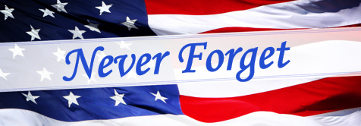They Jeopardized Their Lives for a Cause Greater Than Themselves
2 Samuel 23:13-17
Introduction: For many, Memorial Day is just another Federal holiday, a much-needed three-day weekend where you don’t have to go to work. For some, it’s the weekend of the Indy 500, for others it’s the beginning of summer fun filled with picnics, BBQ’s and maybe an outing to the lake for a day of fishing. But Memorial Day is much more than that, it’s a day of remembrance. Memorial Day is a day we set aside each year to honor the many men and women who gave their lives in service to our country to preserve and protect the freedoms we enjoy today. On this day of remembrance, we want to honor the “blood of heroes”, we must not forget them. Abraham Lincoln said, “A nation that does not honor its heroes, will not long endure.” This morning I want to give you several things we must never forget.
This morning we have Army Veteran Mark Nickic carrying the flag. Mark served in the United States Army 82 Airborne out of Fort Bragg North Carolina during 1964-1967. The 82 Airbourne was a specialized army unit that traveled all around the world as first responders.
OUTLINE

I. We must never forget the men and women who gave their
_________ to protect the freedoms, we enjoy today.

II. We must never forget our _________ who have served and
are now serving to defend our freedoms.

III. We must never forget the __________ that was paid by
Jesus to secure our freedom.
lives veterans price

